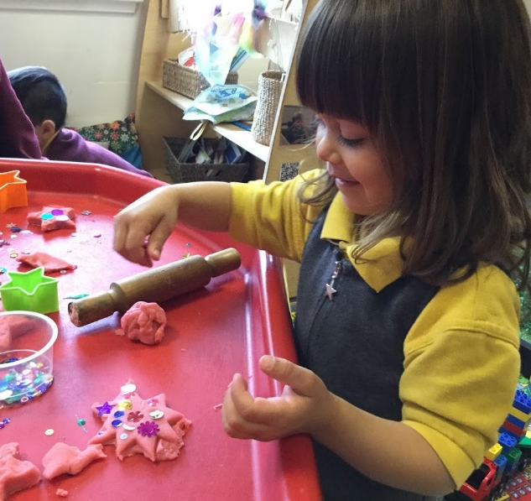
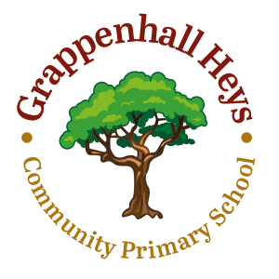

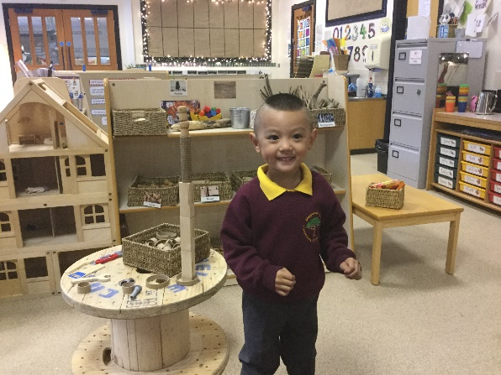
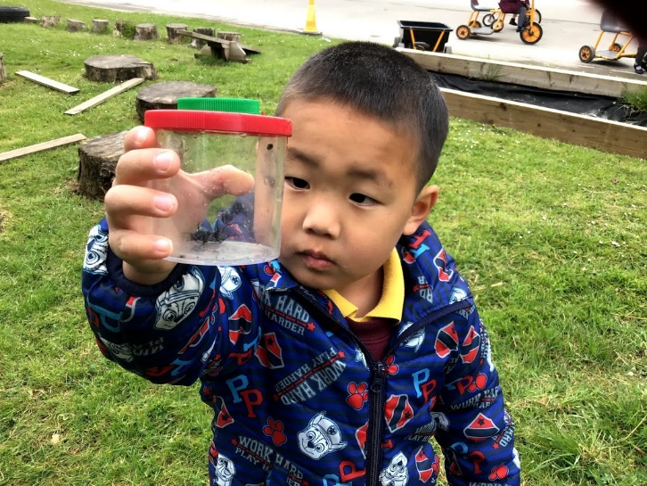
Welcome Booklet
2021- 2022

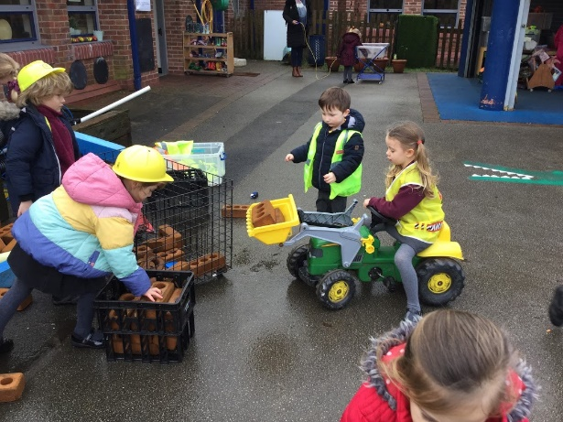

Welcome To Nursery

Beginning Nursery is a major event in the life of a three/ four year old and it won’t be long before your child will be starting Primary School. There will be lots of new things to learn and of course you will want to ensure that your child is well prepared for this important event. We aim to make it a happy and memorable experience. We hope that this booklet will provide some useful information that will help your child settle quickly into school.

Contents

Page

Contact information ………………………………………………………………………………………………………….. 3
Meet the staff …………………………………………………………………………………………………………………… 4
Our vision ………………………………………………………………………………………………………………………….. 5
Parents as partners ……………………………………………………………………………………………………………. 6
Preparing your child for school …………………………………………………………………………………………. 8
The school day …………………………………………………………………………………………………………………… 10
School Uniform ……………………………………………………………………………………………………………………. 11
School Dinners …………………………………………………………………………………………………………………….. 12
Induction Programme .………………………………………………………………………………………………………..11
Learning in the Foundation Stage …………………………………………………………………………………..... 13
Things to bring to school …………………………………………………………………………………………………… 15
Teach me to do it myself! ………………………………………………………………………………………………….. 16

3
General Information

Our contact details are:
Grappenhall Heys Community Primary School,
Stansfield Drive,
Warrington,
Cheshire
WA4 3EA

Telephone: 01925 212 540
Email: grappenhallheys_primary@warrington.gov.uk

School Website: http://www.grappenhallheys.co.uk/

Head Teacher: Ms Kelly Jackson

Meet the Staff

Mrs Gordon
Nursery
Teacher
Mrs Lomas
Nursery
Teaching Assistant

Mrs Colebrook
Reception
Teaching Assistant

Mrs Cunningham
Early Years Lead
Reception
Teacher
Mrs Burgess
Reception
Teaching Assistant

Our Vision

Our aim is to provide a happy, stimulating environment where every child will be given the best possible opportunities to achieve their full potential and an education which will nurture their needs as individuals. We constantly review our provision and in consultation with parents and our wider community, we strive to retain our family ethos whilst also equipping our children for the future.

We hope to encourage a shared commitment to the success of our children, where parents have a positive role in complementing and supporting the work of the school.

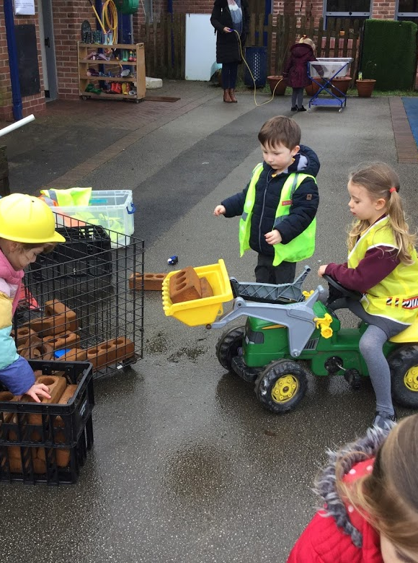
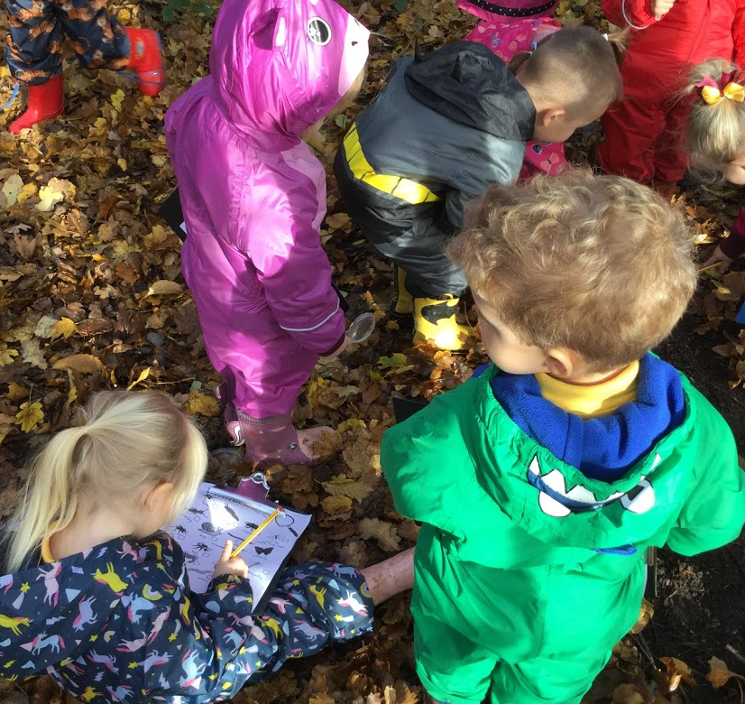

Parents as Partners

We recognise the importance of parents and carers in a child’s developing stages. As a primary care provider, you are your child’s first educators and we greatly value any input, opinions and information you can share with us about your child’s learning and progress.

To support this, we will be using an electronic platform called ‘Seesaw’ to share the work you child does in school. You will have a login for your child’s Seesaw account for you to access at home.

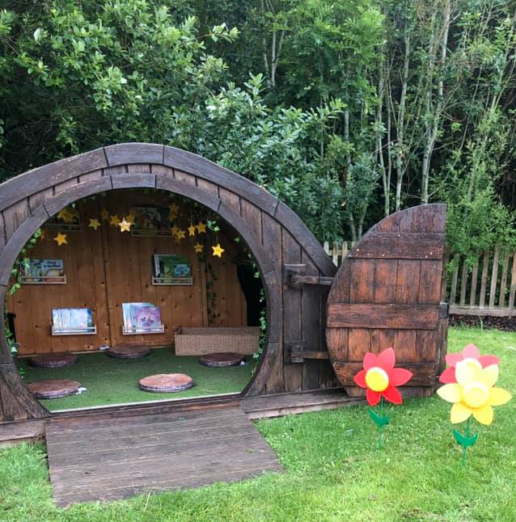
We also encourage you to contribute to these by making small observations at home and ask you to record these on Seesaw. (For example if your child’s target is to identify numbers to 10, you may notice him or her using the remote control to change the channel correctly to channel 3. This is showing us that your child can recognise the number three independently.)
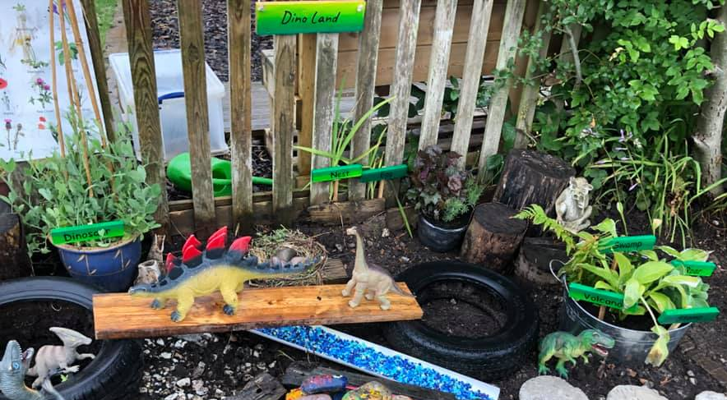

Parents as Partners (continued)

We provide many other opportunities for parents and carers to take an active part in their child’s education. These include:

- Learn with your child events where parents are welcomed to observe their child in the environment followed by focused workshops e.g. phonics.
- Educational Visits where parent-helpers are invited
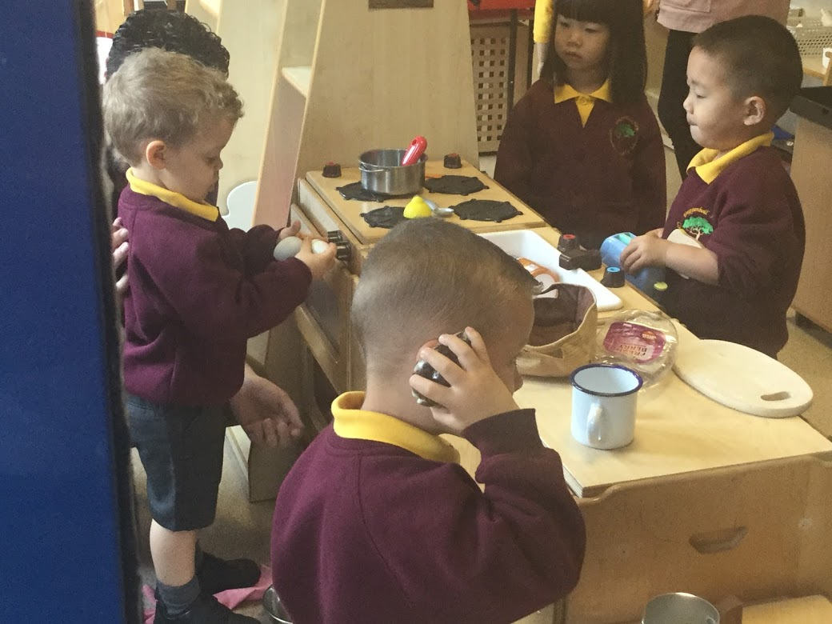
- Sport Events
- Weekly Nursery News updates
- Monthly newsletters
- Class web pages updated regularly
- Open Assemblies

Preparing your child for school

Your child will be in a small class of children. It will make starting school much easier and happier if they are independent and can do many things for themselves.

What should he/she be able to do?

Can he/she…
- Dress and undress themselves?
- Tidy up after himself/herself?
- Recognise their own name? Please tell your child’s teacher if their name is abbreviated in any way.
- Feed himself/herself?
- Share toys and equipment?
- Handle a pencil?
- Sing some nursery rhymes?
- Practise counting to 5?
- Listen well and follow simple instructions?
How can I help my child prepare for school?

- Encourage your child to be as independent as possible even if it takes far longer for them to get ready.
- Get them used to a routine of reasonably early to bed and up early enough for you and your child to have a stress free time to get ready for school.

- Never threaten them with school! Be positive. Show it to them as an enjoyable experience.

The School Day

Start of day- Nursery children assemble outside Nursery Class door. When the Nursery Staff open the door, the children will be welcomed in. Parents should make sure the child has all their equipment and have said their goodbyes before their child reaches the door. Doors open at 8.45 am.
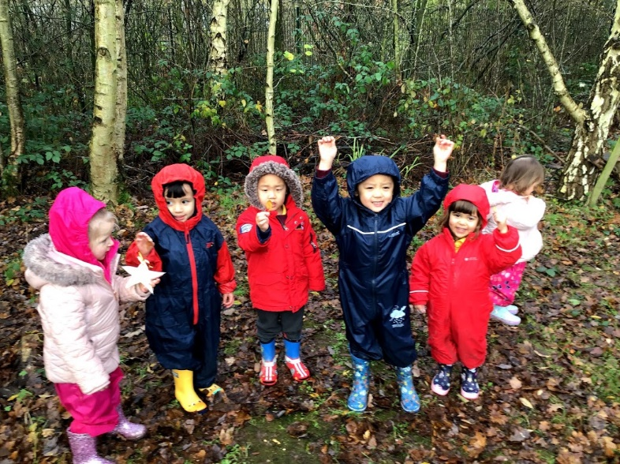
On entering school our children place their water bottles in the crate, will be supported to hang up their coats, self-register and then go and choose an activity in the provision. A member of staff is available to help with learning how to hang up coats and place bags away.

Lates - School begins at 8.55 am. If you arrive after this time you must report to the main reception area so that we can record your child’s late arrival in the registers. Pupils will then be taken to their classroom.

End of day – The end of the Nursery school day is 11:45am. Families are asked to come and collect their child from the Nursery classroom door. The children will be called once the teacher can see a parent or carer. Please inform the class teacher of any arrangements that are made with regards to the collection of your child. We will not be able to release your child to another adult without your written consent.

Snack and Lunch

Lunchtime

Lunchtime is 11.45 – 12.45pm
Children have a cooked school meal, or a packed lunch prepared at home.

School Meals

You may wish for your child to have a school meal every day they are staying for the whole school day or just sometimes, your child will just need to tell the teacher in the morning during registration what their choice is for that day.

Packed Lunches

At Grappenhall Heys Community Primary School, we promote healthy eating. We ask for support in not providing your child with sweets, chocolate, fizzy drinks. We encourage your child to return all uneaten food in their lunch box, so you can monitor what they have eaten.

To ensure the safety of children in the school with nut allergies, please do not include any food that may contain nuts in packed lunches.

Snack
Snack will be available for your child throughout the day. Each morning and afternoon there will be a selection of healthy foods and fruit as well as milk and water.

Learning in the Foundation stage

Nursery is where the excitement begins! Children learn together in an environment which is developed around the children’s interests. We pride ourselves on being an exciting and engaging place to be - encouraging our children to be independent learners through a range of practical activities. We follow a thematic curriculum which allows us to be creative with our lessons and let the children lead their own learning.
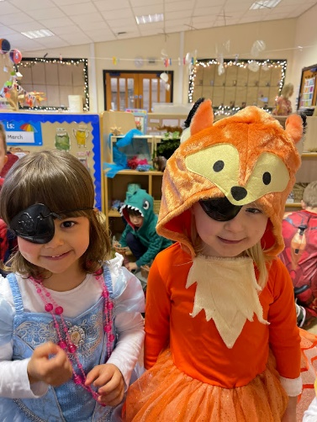
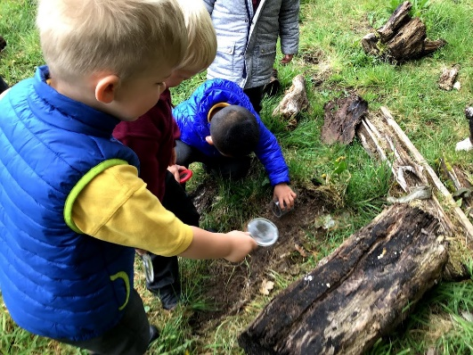
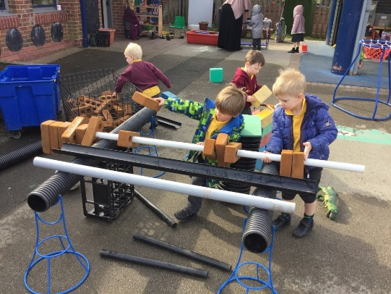
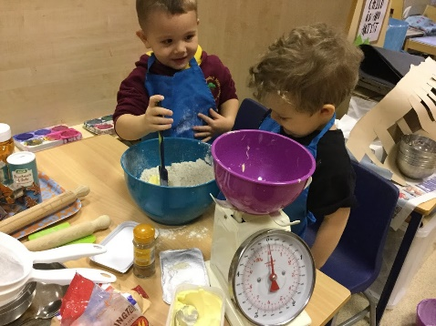
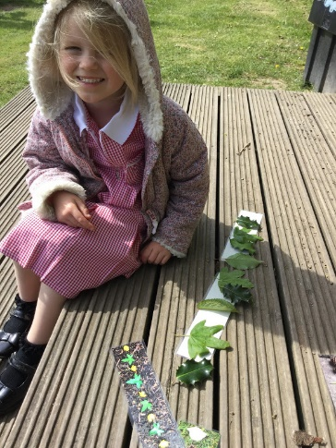
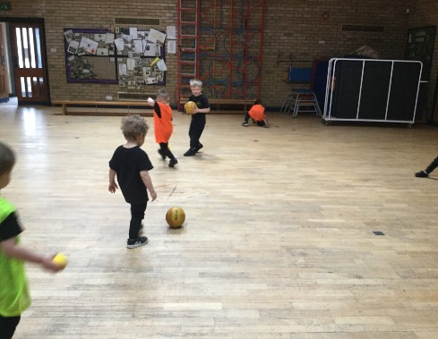

As the Foundation Stage children enter the classroom, they learn primarily through a variety of play and real-life experiences. Our teaching is delivered through carefully planned tasks and guided key jobs. The children access their environment freely and they are encouraged to complete 'challenges' throughout the week which will scaffold and extend their learning. We use ‘Seesaw’ to record individual interests, progress and plan the next steps of your child's learning.
The EYFS Curriculum

In Nursery, children follow the statutory framework for the early years foundation stage (EYFS). This framework is based upon four themes and principles.

These are:

• every child is a unique child, who is constantly learning and can be resilient, capable, confident, and self-assured

• children learn to be strong and independent through positive relationships

• children learn and develop well in enabling environments with teaching and support from adults, who respond to their individual interests and needs and help them to build their learning over time. Children benefit from a strong partnership between practitioners and parents and/or Carers.

• importance of learning and development. Children develop and learn at different rates. The framework covers the education and care of all children in early years provision, including children with special educational needs and disabilities (SEND).

Please look at the ‘Early Learning Goals Guide For Parents’ for information on the New Statutory Early Years Framework 2021.
Things to bring to school

- Wellies and Puddle Suit—we play outside in all weathers!

- Suitable coats—nothing too special as it is likely to get sandy, muddy, or wet.
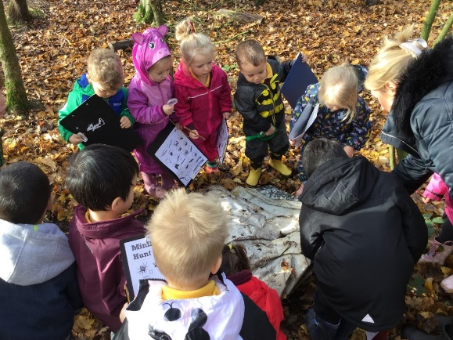

- On cold days- hats, scarves, and gloves

- During the warmer months - sun hats, sun cream and sunglasses.

- Water bottles - labelled please.

- Book bags and reading journals - these are checked and changed regularly.

- PE will be on a Tuesday. Please dress your child in their PE kit on this day.

Helping Prepare your Child for School

Here in Nursery we go to great lengths to help your child be prepared for their next stage of learning; as well as developing the confidence and skills to be an independent learner. Our motto is:

Teach me to do it myself!

In preparation for school, here are some things you can do with your child to help them develop the basic skills on their learning journey.

19
Speaking

- Speak clearly and confidently
- Model using the right words and set an example
- Speak in full sentences
- Use clear, simple directions for tasks and behaviours
- Engage in discussions with your child and allow them the time to speak without being interrupted
- Ask for their opinions
- Tell them about your day and
ask about theirs.
Listening

- Show your child how to be a good listener by listening to them and others
- Be patient—don’t interrupt or finish their sentences for them
- Give them your full attention when they are speaking, showing them eye contact and good body language.
- Respond to what they are saying by asking questions or ask about their opinions.
Number Skills

- Count daily with your child
- Count objects, actions, numbers and a range of things
- Encourage looking at numbers wherever you go- a neighbours house number or the number on a bus
- Help children putting numbers in order
- Let children help with the tidying and sorting. Can they sort the books or toys by colour?
- Look at subitising songs on YouTube.
- Play board games together
- Identify shapes around the home and outdoors
- Use fingers to represent a number

Mark Making Behaviour Organisation

- Encourage your child to mark make without feeling pressured.  - Get your child colourful pens, gel pens and exciting new tools to encourage them to mark make.  - Draw in different mediums: e.g., mud, sand, snow, paint, shaving foam or flour.  - Draw with scarves and ribbons in the air.  - Fill a plastic wallet with paint, sequins and glitter and get them to mark-make over the pattern.  - If your child is already confident with a pen or pencil, support their pencil grip so they do not develop a bad habit.  Extending their learning  - Link your child’s learning to family activities.  - Celebrate your child’s learning and milestones, you are welcome to share them on Seesaw and we can celebrate them with their friends if they would like us to.  - Go to local museums, parks, wildlife reserves and into nature.  - Talk about the world around them and encourage them to ask questions.  - Get to know what your child is learning- we will send home weekly news about what your child has been learning that week for you to discuss at home.  - Take time to listen to your child and explain things carefully, developing their understanding and vocabulary. | - Agree clear and realistic rules- and stick to them.  - Give your child boundaries so they know what is expected of them.  - Encourage your child to always say ‘please’ and ‘thank you’.  - Support the school rules. | - Children like routines- so set regular times for bed, getting up, meals and family time.  - Check that your child has their name in everything before they bring it in, this helps them be organised themselves in school.  - Help your child remember to bring everything- book bag, drinks bottle, reading journal etc.  - Let your child take hold of their own things on the way to school- they will know where to put their coats, bottles, and bags.  - Lay your child’s clothes out in the correct order each morning so they can dress themselves.

