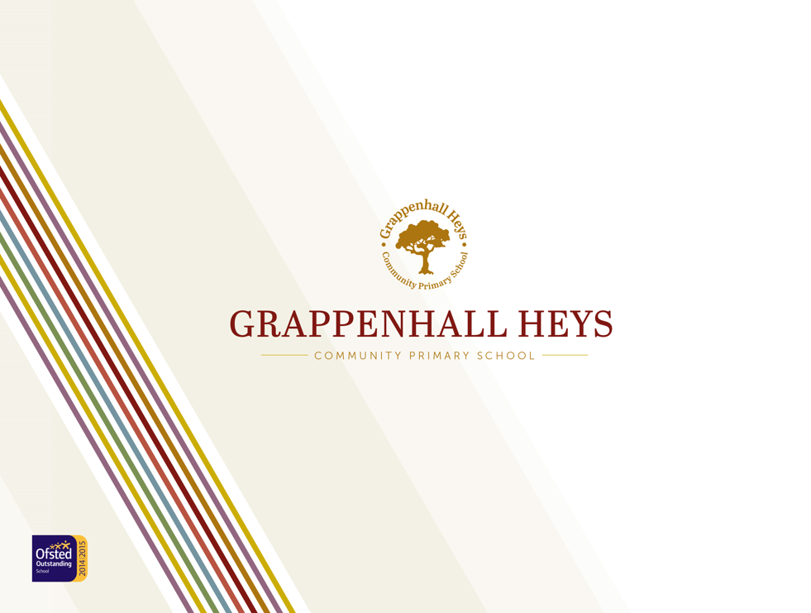
Remote Learning Plan

Remote education provision: information for parents
This information is intended to provide clarity and transparency to pupils and parents or carers about what to expect from remote education where national or local restrictions require entire cohorts (or bubbles) to remain at home. It has been written, taking into account the following published guidance:
- Department for Education: Review your remote education provision
- Ofsted: What’s working well in remote education

National expectations
In developing their remote education, we expect schools to:  - teach a planned and well-sequenced curriculum so that knowledge and skills are built incrementally, with a good level of clarity about what is intended to be taught and practised in each subject so that pupils can progress through the school’s curriculum  - select a digital platform for remote education provision that will be used consistently across the school in order to allow interaction, assessment and feedback and make sure staff are trained and confident in its use. | When teaching pupils remotely, we expect schools to:  - set meaningful and ambitious work each day in an appropriate range of subjects  - provide teaching that is equivalent in length to the core teaching pupils would receive in school. This will include both recorded or live direct teaching time and time for pupils to complete tasks and assignments independently (Online video lessons do not necessarily need to be recorded by teaching staff at the school: Oak National Academy lessons, for example, can be provided in lieu of school-led video content)  - consider how to transfer into remote education what we already know about effective teaching in the live classroom by, for example:  - provide frequent, clear explanations of new content, delivered by a teacher or through high-quality curriculum resources  - provide opportunities for interactivity, including questioning, eliciting and reflective discussion  - provide scaffolded practice and opportunities to apply new knowledge  - enable pupils to receive timely and frequent feedback on how to progress, using digitally-facilitated or whole-class feedback where appropriate  - use assessment to ensure teaching is responsive to pupils’ needs and addresses any critical gaps in pupils’ knowledge  - avoid an over-reliance on long-term projects or internet research activities  We expect schools to consider these expectations in relation to the pupils’ age, stage of development or special educational needs, for example where this would place significant demands on parents’ help or support.

Teaching and Learning
What will my child be taught during a period of remote learning? | There is a plan in place for remote education and a senior leader with overarching responsibility for the quality and delivery of it, including that provision meets national expectations for remote education.  The plan is underpinned by high expectations to provide the quality delivery of a planned curriculum for all (including vulnerable children and children with SEND) which is aligned as close as possible to the in-school curriculum, with some minor adaptions.  School has a clear, well-sequenced curriculum for pupils in class and those working remotely.
How long can I expect the work set by school to take my child each day? | Minimum provision  School sets work that is of equivalent length to the core teaching pupils would receive in school in an appropriate range of subjects, and as a minimum:  - Key stage 1: 3 hours a day, on average, across the school cohort, with less for younger children  - Key stage 2: 4 hours a day  Pupils understand the expectations on how many hours they should be learning and how to participate in remote education (for example, how to submit/upload work). This is because homework is set using the same platform.  Pupils will be provided with a daily reading session, English and Maths lesson and one other curriculum subject. Children in EYFS and KS1 will also have access to a daily phonics session and a story session.
How will my child be taught remotely? | The school has a system in place to support remote education, using curriculum-aligned resources.  Where remote education is taking place, it should include a balance of recorded or live, direct teaching time from the school or other educational providers (such Oak National Academy and BBC bitesize) and time given for pupils to complete tasks and assignments independently. It should be appropriate for the age and meet the needs of the children.  The school uses digital platforms to support effective communication and accessibility for all pupils, including those with SEND. They will also use a range of commercially available platforms which the school has subscribed to. Children will be familiar with these platforms as they are frequently used within school or as part of homework.  Children in EYFS will access remote learning via Evidence Me. KS1 and KS2 will access remote learning via Seesaw. All classes will use Google Meet as a platform for live teaching and learning and social interaction.  Other online platforms include:  - Rising Stars- Reading Planet and Cracking comprehension  - Numbots and Times Table Rock Stars  - Spelling Frame  - White Rose materials and video clips  - Purple Mash  - Learning by Questions (LBQ)  Communication to parents is provided through ParentMail, as well as the online learning platforms.  The school has a robust system in place to support our remote learning and follows the Warrington agreed model.  Children will take part in a daily morning registration session via Google Meet. During this time the teacher will ensure that they are well and have everything they need to undertake the day’s activities. This session may then be extended as a live session into the first lesson.
Accessibility
How will my child access any online remote education being provided by the school? | Children in EYFS will access remote learning via Evidence Me. KS1 and KS2 will access remote learning via Seesaw. All classes will use Google Meet as a platform for live teaching and learning and social interaction.
What happens if my child does not have access to a digital device | Pupils who lack digital access to support the remote education provision will be supported by school by providing them with a laptop and/or internet access.  Where digital approaches are used, leaders are aware of any limitations to access to the internet, and suitable devices, for pupils which impact on remote education provision. Leaders have made suitable alternative arrangements to minimise the impact of these limitations, either by providing pupils with devices and/or internet access or ensuring appropriate offline provision where pupils without access are considered vulnerable and are expected to come into school.
Engagement and feedback
What are your expectations for my child’s engagement and the support that we as parents and carers should provide at home? | We expect daily engagement from all children. This may be attending a live session or uploading work via the online platform. If a child does not engage, the Classteacher will attempt to contact the child’s parents. If this continues, the Headteacher will be informed. If contact with the child/family cannot be made, a doorstop visit will be conducted by 2 staff members as part of our safeguarding arrangements.
How will you check if my child is engaging with their work and how will I be informed if there are any concerns? | The school has systems for checking whether pupils are engaging daily with their work, and informs parents and carers immediately where engagement is a concern.  Staff will make phone calls to check any concerns around wellbeing, work or engagement. Parents are aware they can contact staff (Classteacher/Headteacher) in school at any time if need be, via telephone or email.
How will you assess my child’s work and progress? | The school has a plan in place to gauge how well all pupils are progressing through the curriculum using questions and other suitable tasks.  The school provides feedback daily, using digitally-facilitated or whole-class feedback where appropriate. Feedback may be in the form of liking, commenting or providing live feedback on work. Teachers may also record verbal feedback in response to an uploaded piece of work (this works particularly well for our younger children).  Learning by Questions software, particularly in Key Stage 2, allows for instant feedback for children as they work through set questions.  We use rewards such as ‘Special mention’ certificates to encourage and reward the children. Headteacher Awards sent in the post and a virtual class sticker chart is used to maintain engagement and motivation when working remotely. Classteachers also use good examples of work on the class blog to showcase to the rest of the class and children can also use the class blog to share work that they are proud of.
Additional support for pupils with particular needs
Children and young people with high needs, including disadvantaged pupils, SEND and vulnerable pupils, have the right structures and provision in place to help with remote education if they cannot be in school. This includes guidance for parents and carers on how to effectively support remote education, and ensuring pupils have access to the right hardware and software to support their needs.

Children with Intervention Plans/EHCPs in mainstream school will be receiving differentiated work if they are unable to access the work that has been set for the rest of the class. Additional sessions and interventions may be offered if there is capacity to do so.

Pupils are given opportunities to attend and participate in shared, interactive lessons and activities to maintain a sense of community and belonging, especially disadvantaged and SEND pupils.

Safeguarding, Health and Safety
There are clear safeguarding protocols in place to ensure pupils are safe during remote education. It is essential to have and communicate clear reporting routes so that children, teachers, parents and carers can raise any safeguarding concerns in relation to remote education.

Parents and carers are able to raise any safeguarding concerns at any time. Staff continue to use the school based systems for reporting any concerns.

If the school chooses to provide remote education using live streaming and pre-recorded videos, teachers understand how to keep children safe whilst they are online and there are clear protocols in place.

Our remote learning offer aims to provide a balance of on and off screen activities and prioritises active learning, where possible.

Data protection | The school has appropriate data management systems in place which comply with the General Data Protection Regulation (GDPR).
Wellbeing
Leaders, teachers and pupils are aware of how to spot potential wellbeing or mental health issues and how to respond.
There are regular catch ups with pupils, including one to one or small groups particularly for those that are most vulnerable.

Wellbeing is an integral part of our curriculum, sessions such as yoga, meditation, listening to music, and drawing are built into the weekly timetable.

Behaviour:

There are clear rules for behaviour during remote lessons and activities. Pupils know them and teachers monitor and enforce them.

The same rules and expectations apply as when we teach the children in school. Staff will make parents aware about any inappropriate behaviour.

