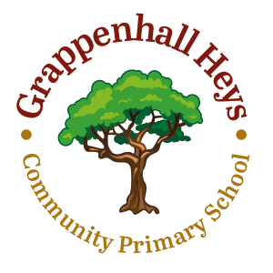**EYFS**

**Calculation Policy**

|  |  |
| --- | --- |
| **ADDITION**  Addition is taught using objects and pictures.  If I have 2 and then 5 more, how many is that altogether? The number calculation is written underneath.  Begin to **count on** using a number line.  The use of fingers and objects is encouraged to develop an understanding of the value of each number and the concept of addition. | **SUBTRACTION**  Subtraction is taught using objects and pictures.  What do I get if I take 2 away from 6? The number calculation is written underneath    Begin to **count back** using a number line.  Begin to **count on** using a number line.  The use of fingers and objects is encouraged to develop an understanding of the value of each number and the concept of subtraction. |
| **MULTIPLICATION**  Multiplication is taught using objects and pictures.  **Counting groups** of objects or pictures  2 groups of 4 are 8  Using **arrays** to solve simple multiplication problems.  2 groups of 4 are 8 | **DIVISION**  Division is taught using objects and pictures.  Objects are **shared** between two piles. This is done practically first and then through informal jottings. |