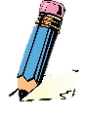
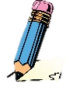
WRITING
EYFS LEARNING IN
KNOWLEDGE ORGANISER
Overview |  |  |  |  | Literacy - Writing |  |  | Key Vocabulary  Writing  Letters  Words  Sentences  Pencil  Vowels  Consonants  Punctuation  Phonics
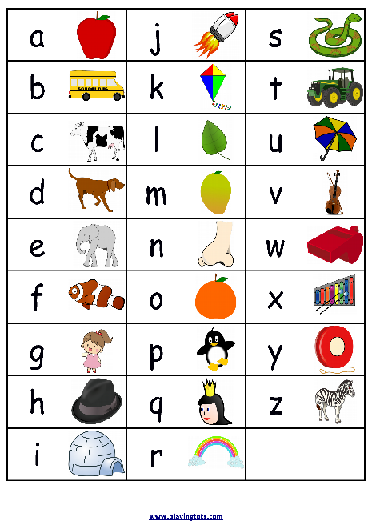  Writing  -When writing, we use letters and symbols to communicate our ideas to readers.  Writing skills are built on strong speaking and reading skills. As these develop, children move from mark making to forming letters and words.  In EYFS, early writing knowledge is based within the ‘Literacy’ , ‘Communication & Language’ and ‘Physical Development’ learning areas. |  |  |  |  | Handwriting  -Writing should be able to be read by others. Know that there are small letters: a c e i m n o r s u v w x and z. Some letters are taller (ascenders): b d h l and t. Some letters go below the line (descenders): g j p q y.  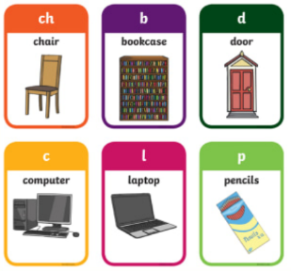  Vocabulary Sub-Area: Speaking  -Vocabulary means the words that we know.  -We should try to learn as many different words as we can, so that we can read and write clearly.  -We should be able to write some CVC (consonant, vowel, consonant) and CVCC words correctly.  Names and Labels Sub-Area: Writing  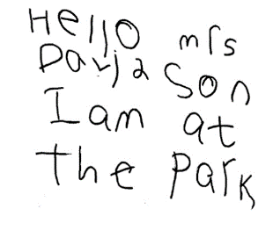  -We should be able to write our name, and some other familiar words (words that we know well) e.g. mum, dad, sibling’s name etc.  -We can also spell label familiar places, animals and objects with accuracy, e.g. shop, car, dog, duck,  Simple Sentences  -A sentence is a group of words put together to mean something. We should start to write sentences that have a real meaning, and can be read by others.
Literacy - Phonics
-Phonics is a way of learning to read, by understanding the sounds that letters make.
In EYFS, children should use their phonic knowledge in order to write words to match their spoken sounds. They can also spell some common tricky words, that do not follow phonic patterns.
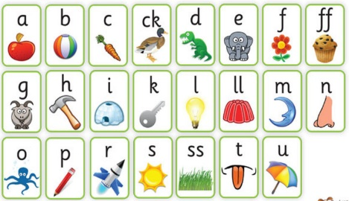 | Phase 2  Sub-Area: Reading | -In Phase 2, we learn the letter names. We also learn the sounds of the Phase 2 letters (on the left).  -We blend the sounds together, e.g. ‘D-O-G – Dog.’  Tricky words: the, to, I, no, go, into  High frequency words: a, an, as, at, if, in, is, it, of, off, on, can, dad, had, back, and, get, big, him, his, not, got, up, mum, but.
 |  |  |  |  | Physical Development – Pencil Grip Stages
 |  |  |  |  | 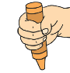 | Fisted Grasp:  1-2 years old | -Pencil held in palm. All fingers and thumb used.  -Movement is from the shoulder  -Large scribbles are made on the page.
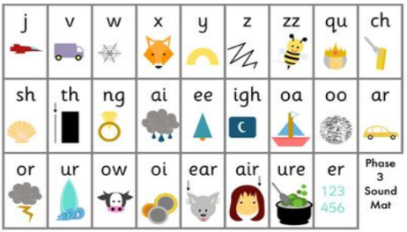 | Phase 3  Sub-Area: Reading | -We should reach the end of Phase 3 by the end of the Reception year. Phase 3 has many more digraphs (two letters making one sound.  Tricky words: he, she, we, me, be, was, my, you, they, her, all, are High frequency words: will, that, this, then, them, with, see, for, now, down, look, too. |  |  | 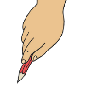 | Digital Pronate Grasp  2-3 years old | -All fingers hold pencil. Wrist is turned down.  -Movement is from the elbow.  -Horizontal, vertical and circular lines are now added.
 |  |  |  |  | 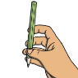 | Four Finger Grasp  3-4 years old | -Pencil held between the end of four fingers and thumb.  -Movement is from the wrist.  -Zigzag/crossed lines and simple shapes can be drawn.
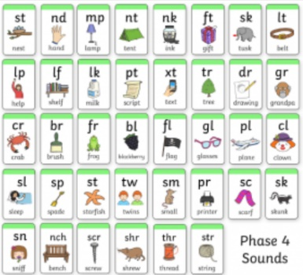 | Phase 4  Sub-Area: Reading | -Some children will be able to reach Phase 4 in Reception. There are no new sounds, just ‘adjacent consonants’ (2 consonants together making 1 sound).  Tricky words: said, so, have, like, some, come, were, there, little, one, do, when, out, what  High frequency words: went, it’s, from, children, just, help. |  |  | 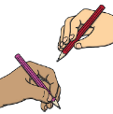 | Static Tripod Grasp  4-6 years old | -Pencil held between the index, middle fingers & thumb.  -Fourth finger sometimes involved.  -Movement is normally still from the wrist.  -Shapes such as triangles and squares can be drawn.
 |  |  |  |  | 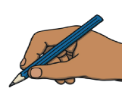 | Dynamic Tripod Grasp  6-7 years old | -Pencil stable between index, middle fingers & thumb.  -Movement is from the fingertips.  -This allows for more flexibility and accuracy.
At the end of the Reception year, children use some of these words to write simple sentences.

Literacy – Symbols
a e i o u
Vowels
123
Numbers
abc
Small/ Lower-Case Letters
ABC
Capital Letters
?
Question Mark
Full Stop

