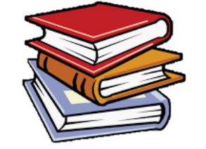
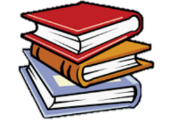
READING
EYFS LEARNING IN
KNOWLEDGE ORGANISER
Overview |  |  |  |  | Communication and Language | Key Vocabulary  Reading  Books  Letters  Sounds  Words  Sentences  Vowels  Consonants  Phonics
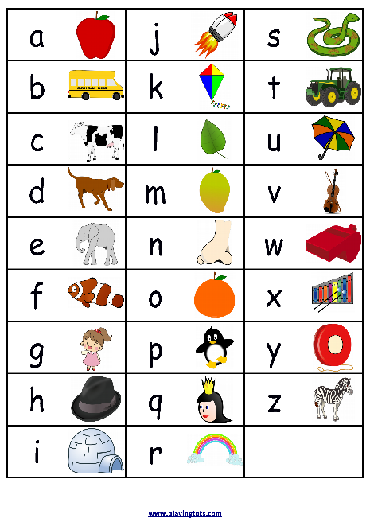  Reading  -In Reading, we look at letters and symbols in writing, and work out what they mean.  Reading is like breaking a special code!  -We use our eyes to see letters and symbols, and our brains to work out the words and sentences that they form.  In EYFS, early English knowledge is based within the ‘Literacy’ and ‘Communication & Language’ learning areas. |  |  |  |  | 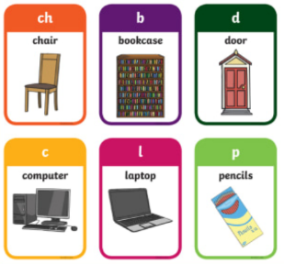  Vocabulary Sub-Area: Speaking  -Vocabulary means the words that we know.  -We should try to learn as many different words as we can, so that we can read and write clearly. When you are reading, try to remember new and unfamiliar words to build your vocabulary.  -e.g. Vocabulary meaning ‘big:’ large, huge, great, enormous.  Questions Sub-Area: Understanding  -Questions are used to ask something. They try to find out information & end with question marks. e.g. What is your name? or Where is the shop?  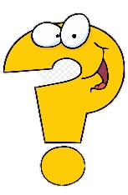  -Questions that begin with ‘how’ and ‘why’ (open questions) are great for finding out information in more detail.  e.g. ‘How did the dinosaurs die out?’ or ‘Why is the sky blue?’  Rhyme and Jokes  -Rhyme is when words have the same ending sounds, e.g. bat, cat, mat.  -Jokes are things that are funny. Jokes are used to make us laugh!
Literacy - Phonics
-Phonics is a way of learning to read, by understanding the sounds that letters make.
There are 26 letters in the alphabet: A B C D E F G H I J K L M N O P Q R S T U V W X Y Z
Letters can be either vowels (A, E, I, O and U) or consonants (all of the other letters).
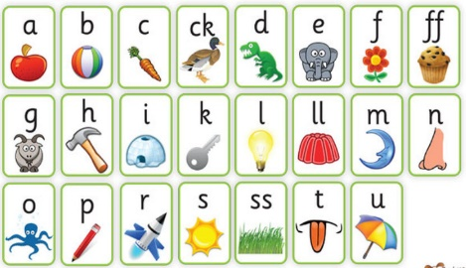 | Phase 2  Sub-Area: Reading | -In Phase 2, we learn the letter names. We also learn the sounds of the Phase 2 letters (on the left).  -We blend the sounds together, e.g. ‘D-O-G – Dog.’  Tricky words: the, to, I, no, go, into  High frequency words: a, an, as, at, if, in, is, it, of, off, on, can, dad, had, back, and, get, big, him, his, not, got, up, mum, but.
 |  |  |  |  | Literacy – Reading Books
Books
-A book is made up of pages, which have words and pictures printed on them.
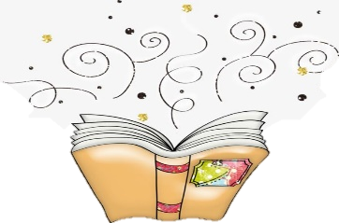
-Books should be read from left to right and from top to bottom.
-There are lots of different types of books, for example: stories, fairy tales, picture books, information books, poems and plays.

Stories
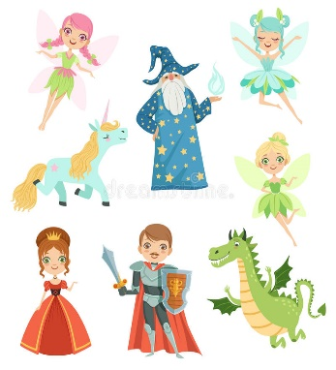
-Many books contain stories. Stories tell us about events or something that has happened to someone. Most stories have a clear beginning, middle and end, e.g.
-Beginning – The hare challenged the tortoise to a race.
-Middle – The hare was winning, but fell asleep under a tree.
-End – The tortoise overtook the sleeping hare and won the race.
Stories always have:
-Characters – The people, animals, creatures or living things in a story.
-Events – The things that happen in the story.
-Setting – Where the story takes place.
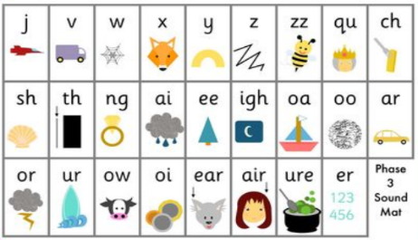 | Phase 3  Sub-Area: Reading | -We should reach the end of Phase 3 by the end of the Reception year. Phase 3 has many more digraphs (two letters making one sound.  Tricky words: he, she, we, me, be, was, my, you, they, her, all, are High frequency words: will, that, this, then, them, with, see, for, now, down, look, too.
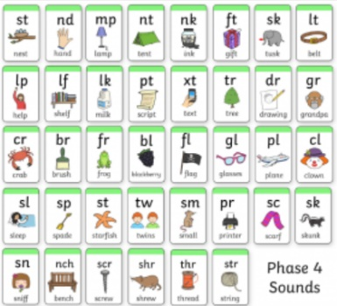 | Phase 4  Sub-Area: Reading | -Some children will be able to reach Phase 4 in Reception. There are no new sounds, just ‘adjacent consonants’ (2 consonants together making 1 sound).  Tricky words: said, so, have, like, some, come, were, there, little, one, do, when, out, what  High frequency words: went, it’s, from, children, just, help.  To test phonics, children may be given ‘alien words’ – nonsense words made up of phonics sounds.

a e i o u
Vowels
123
Numbers
abc
Small/ Lower-Case Letters
ABC
Capital Letters
?
Question Mark
Full Stop
Symbols

